Lab 2 : Threads

Name : Louay Magdy AbdelHalim Ali
ID : 19016195

Code Organization & main functions description
1st: variables
most of variables will be found global such as the three matrices A, B, and C. their dimesions together with pointers to the files from which they are read / written.
You will also find a user defined struct to hold the row and column index in case of thread per element
2nd: File-Reading & tokenization functions
file-reading are the first functions to be executed :
- there is a function called create files that create files that we will write to it but the the input files as a.txt and b.txt have to be existed
- there is a function called read files that read contents of the input files and classify input according to :
  - which matrix is addressed
  - whether the line read is the first line that contain dimensions where split goes over spaces then = sign or it is any other line where we can split the line over spaces or tabs to get the entries
- there is a function called create Custom files that deals with main function argv parameter to get the name of custom files
note : the user must create the custom files or a.txt and b.txt in case they are not found
3rd: first-type thread functions
there are 2 functions :
- thread per matrix function to create the single thread responsible for the operation and make sure that the matrices can be multiplied
- multiply matrix by matrix function that multiplies the 2 matrices together and write the result into files as well → thread function

4th: second-type thread functions
there are 2 functions :
- thread per row function that make sure that matrices can be multiplied and if so, it creates a thread for each row in matrix A
- multiply row by matrix function that multiplies a row of given index with matrix B as a whole → thread function

5th: third-type thread functions
there are also 2 functions :
- thread per element function that make sure that functions can be multiplied and creates a thread for ever row in A and col. in B
- multiply row by col function that multiplies a given row in A with a given col. in B to get an entry in C and notice that all the function requirements are set before the loop of creating threads so as not to introduce any overhead during thread creation → thread function

How to compile and run the code
- Open the terminal and change the directory till you get in the directory where the project is main.c file of project is located
- run the following commands : gcc main.c -o matMultp -pthread
- now the code is compiled. change your directory to : cmake-build-debug
- open the the executable file matMultp found there using : ./matMultp or ./matMultp args. In case there are custom input files but make sure you have created them In the project file
you can also compile it using:
- command make In the project directory
- running the executable matMultp1 found in cmake-build-debug directory

Sample Cases:
1- testing prog
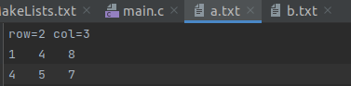

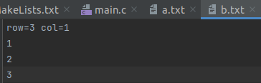

result
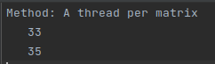
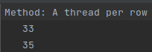

2- testing prog.
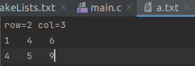

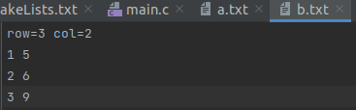

result:
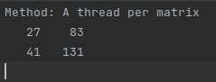
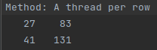
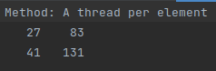

3 – testing from the executable file and seeing the result in the console
also the files have these values printed
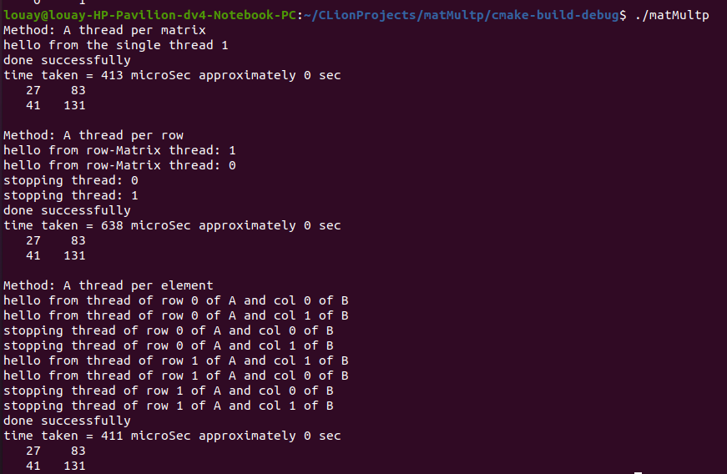
4 – testing using custom arguments
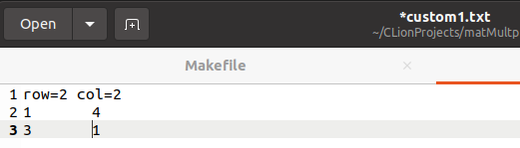
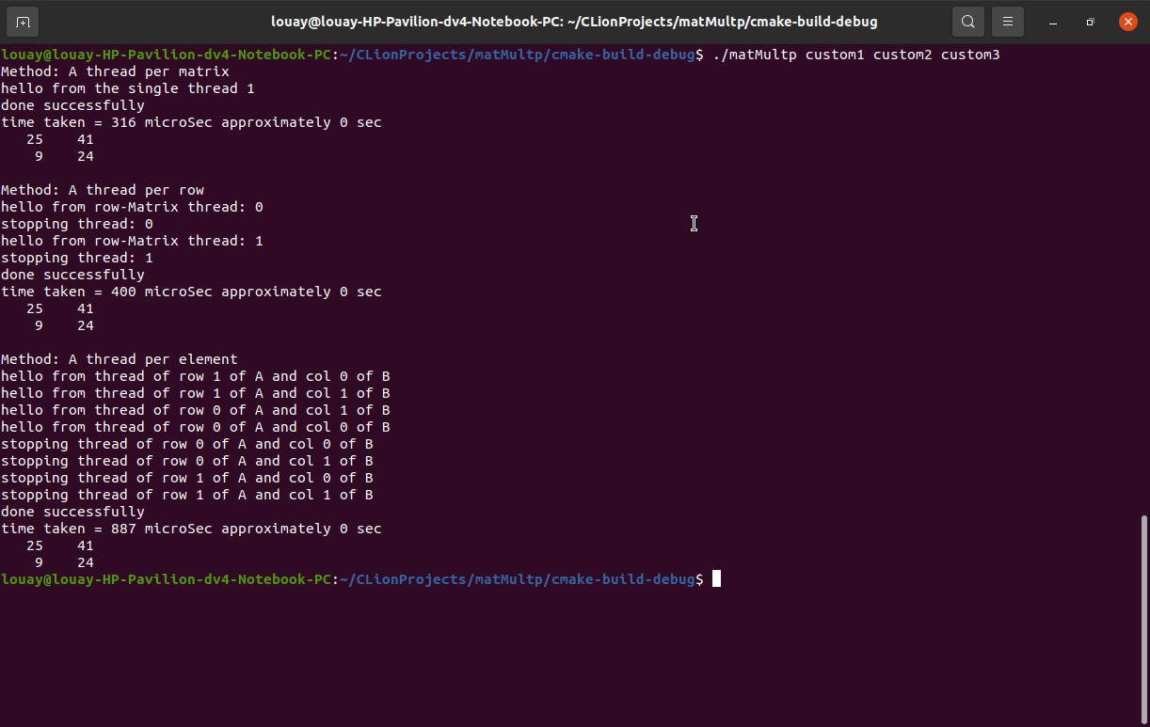
seeing one of the resulting files custom3_per_element.txt
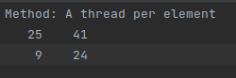

Comparison between the three methods according to time taken :
running various cases :
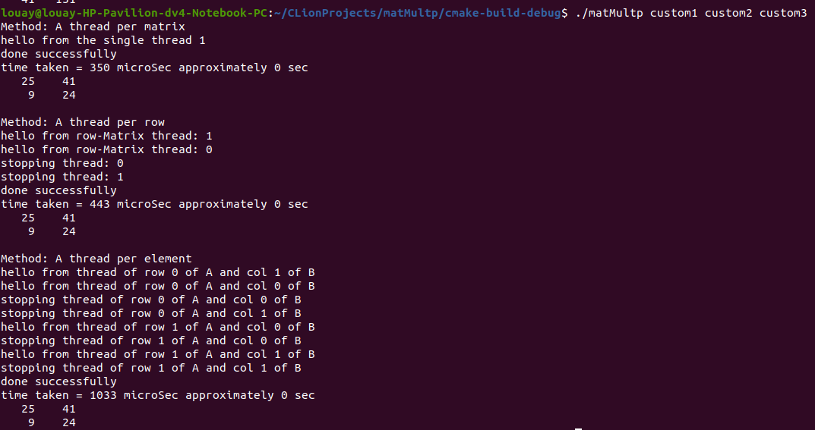
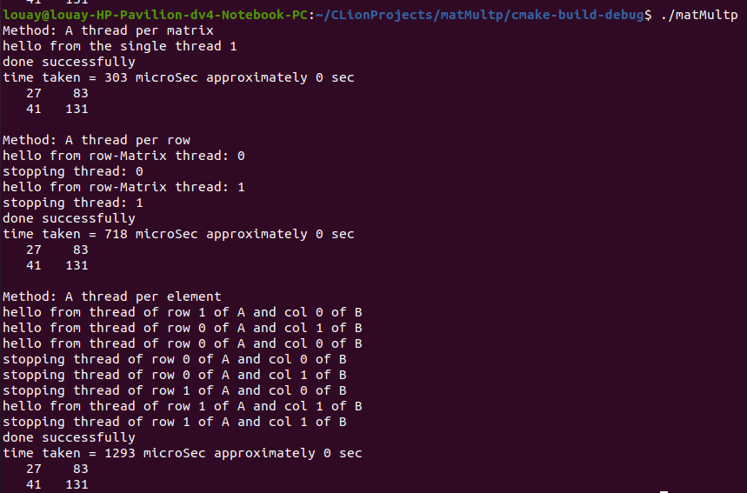
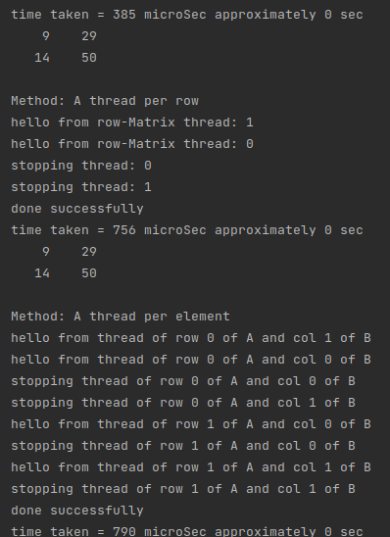

it seems in normal cases, that the single threaded application is the fastest at all although of its high time complexity O(n³) but the thread creation/join overhead which is large is very small compared to the other two function where there are many threads
it seems also that thread per row function will be faster than thread per element because the time complexity of each thread function in the thread per row function is more than that in thread in element (get rid of high complexity in parallel). Also the overhead is less in case of thread-per-row function

